9th Postgraduate Conference – Friday 14th June

‘Medievalism Transformed’

**Magic in the Web of It:**

**Sorcery and the Supernatural**

**in the Middle Ages**

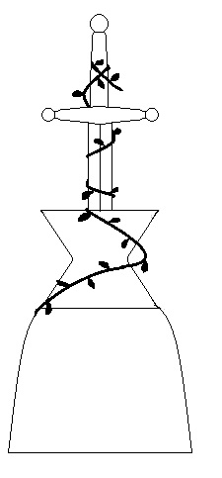

**Programme**

9:30 – 10:00 Registration and Tea/Coffee

10:00 – 10:30 Opening Remarks: ‘Thinking About Dead People’

**Professor Emeritus P. J. C. Field** (Bangor University)

10:30 – 12:30 **Session 1**

Chair: **Ambra Finotello** (Bangor University)

**Alexander Payne** (Exeter University)

Revenants*, Draugr* and Dreams: The Shared World of the Dead in Thietmar of Merseburg’s *Chronicon* and Scandinavian Saga

**Anna Dow** (Durham University)

The Craft of the Supernatural ‘Ymage’ in Late Medieval Romance

**Chiharu Hasegawa** (Bangor University)

Magician, Tactician or Devil?: Ambiguity in Merlin’s Identity in Malory’s ‘The Tale of King Arthur’

12:30 – 13:30 Lunch break

13:30 – 14:30 **Keynote speech**

Chair: **Dr Katharine Olson** (Bangor University)

**Dr Catherine Rider** (Exeter University)

Treating Magical Illnesses in the Middle Ages

14:30 – 16:00 **Session 2**

Chair: **Daisy Le Helloco** (Bangor University)

**Dr Angelika H. Rüdiger** (Bangor University)

Calling Gwyn ap Nudd and His Queen: Discussing a Medieval Folk Custom in the context of British and European literature and custom

**Natalie Moore** (Durham University)

Supernatural Similarities in Hagiography and Romance: Overlapping motifs in the Middle English *St. Erkenwald* and *Sir Amadace*

**Rosemary Kitching** (Manchester University)

Subtle Crafts and Marvellous Salves: Instances of Magical Healing in Sir Thomas Malory’s *Morte Darthur*

16:00 – 16:15 Tea/coffee break

16:15 **Round Table**

**Dr Raluca Radulescu** (Bangor University)

**Dr Sue Niebrzydowski** (Bangor University)

**Dr** **Christian Leitmeir** (Bangor University)



This event is supported by

School of English

College of Arts and Humanities

Graduate School of Bangor University